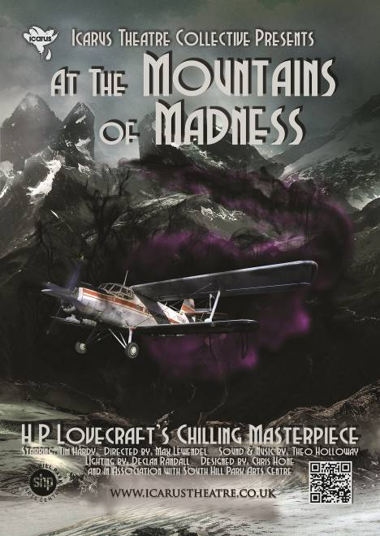
Icarus Theatre Collective presents Tim Hardy in
At the Mountains of Madness


by HP Lovecraft
Starring Tim Hardy

World Premiere
International Tour
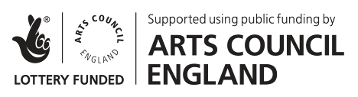
YOUR VENUE
DATA
HERE

Icarus Theatre Collective brings you a World Premiere, the first theatre adaptation of H.P. Lovecraft’s chilling masterpiece “At the Mountains of Madness.” William Dyer is brought vividly to life, trapped and tormented by visions of what he saw – and what he could not possibly have seen – in those ancient, Antarctic mountains of madness.
For nearly a century, this cornerstone of Weird fiction has thrilled readers with its tale of a disastrous expedition to Antarctica, and the awful implications of what was discovered.
After their successful collaboration on The Trials of Galileo touring Malta, Spain, the Edinburgh Fringe, America, and the UK, RSC actor and RADA faculty Tim Hardy rejoins the collective for his 50th year working in the industry as the leader of the ill-fated expedition, offering theatre audiences a masterclass in acting.
Estimated Running time: 1h10m
Press on Tim Hardy in
The Trials of Galileo:
Wandsworth Radio
Fringe Review
Edfringe.com
The Public Reviews
Remotegoat
View from the Gods
British Theatre Guide
Broadway Baby
Three Weeks

"Icarus Theatre fly into London on waxen wings which show no sign of melting any time soon".
-Remotegoat

Born in Rome, Tim Hardy was educated at St. Paul’s School, London. Early on he played the title role in Comus by John Milton before Her Majesty the Queen and His Royal Highness the Duke of Edinburgh leading to him winning a place at the Royal Academy of Dramatic Art (RADA) with a scholarship.

Television credits include the title role in Galileo and Arthur Taylor in Oscar Wilde opposite Sir Michael Gambon for the BBC, Jesus in Son of Man, John Rampayne in The Trial of Sir John Rampayne opposite Sir Ian McKellen, The Doctor in The Wife of Bath opposite Julie Walters, David Manners in Eastenders, leading roles in Midsomer Murders, Rabbi in Casualty 1909, and Ross in Macbeth. Films credits include Captain Corelli’s Mandolin, The Duelist, Nothing but the Best, and Marat\Sade.
Company Website: www.icarustheatre.co.uk

Proudly supported by Creative Scotland & Arts Council England

